Kalubowila G.N

IT24103519

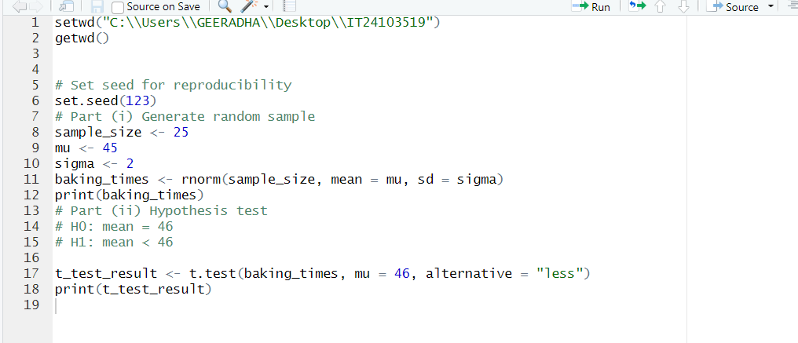

Answers

